|  |  |  |
| --- | --- | --- |
| Project Design Document | |  | | --- | | *03/08/2020*  *CH* | |

|  |  |  |  |
| --- | --- | --- | --- |
| Project Concept | | | |
| 1 **Player Control** |  | You control a   |  | | --- | | Bird | | in this   |  |  | | --- | --- | | Perspective camera with third person view | game | |
|  | where   |  | | --- | | *WS*  *AD*  *Left Shift*  *BC*  *SPACE* | | makes the player   |  | | --- | | *Makes the bird flap harder/less hard*  *Turns the bird*  *Move the bird forward*  *Activates beak and claw respectively*  *Play/Pause* | |

|  |  |  |  |  |  |  |
| --- | --- | --- | --- | --- | --- | --- |
| 2 **Basic**  **Gameplay** |  | During the game,   |  |  | | --- | --- | | *Seed boxes are* | Collected | | from   |  | | --- | | *Furniture around the house* | |
|  | and the goal of the game is to   |  | | --- | | *Survive by eating seed* | | |

|  |  |  |  |  |  |
| --- | --- | --- | --- | --- | --- |
| 3 **Sound**  **& Effects** |  | There will be sound effects   |  | | --- | | *Thud when dropping seed*  *Happy chirp on feed meter filled* | | and particle effects   |  | | --- | | *Seed falls onto floor emitted from dropped box*  *Particles disappear as eaten* | |
|  | [*optional*] There will also be   |  | | --- | | *water sound and shower effect if bird uses sink/shower* | | |

|  |  |  |  |  |  |
| --- | --- | --- | --- | --- | --- |
| 4 **Gameplay**  **Mechanics** |  | As the game progresses,   |  | | --- | | *Seed boxes will be hidden* | | making it   |  | | --- | | *harder to find food for flying energy* | |
|  | [*optional*] There will also be   |  | | --- | | *If showering Implemented, have hygiene bar too.* | | |

|  |  |  |  |  |  |  |  |
| --- | --- | --- | --- | --- | --- | --- | --- |
| 5 **User**  **Interface** |  | The   |  | | --- | | *Food & Hygiene bars* | | will   |  | | --- | | *decrease*  *increase* | | whenever   |  | | --- | | *with time*  *with eating/showering* | |
|  | At the start of the game, the title   |  |  | | --- | --- | | *Bird Simulator 2020* | will appear | | | and the game will end when   |  | | --- | | *Bird has no more energy/is too dirty* | |

|  |  |  |  |
| --- | --- | --- | --- |
| 6 **Other Features** |  | |  | | --- | | *Menu for chapter selection*  *Story mode:*  *Level one - learn to fly (bedroom only)*  *Level two - learn to eat visible seed boxes (bedroom only)*  *Level three - open cage and cupboards/drawers to find food (bedroom only)*  *Level four - (if taps Implemented) take a shower (bathroom only)*  *Free play:*  *Get achievements (full house)*  *Stretch goals:*  *Achievements, find all showering spots, find all food caches*  *Make nicer cage and bird*  *Storytelling between levels* | |

# 

# Project Timeline

|  |  |  |
| --- | --- | --- |
| Milestone | Description | Due |
| **#1** | |  | | --- | | * *Player control and solid walls, no animations, (level 1) and menu* | | |  | | --- | | *07/08* | |
| **#2** | |  | | --- | | * *Seed spawning and consumption in visible places (level 2)* | | |  | | --- | | *12/08* | |
| **#3** | |  | | --- | | * *Interact with cupboards and drawers. Seed now in hidden locations (level 3)* | | |  | | --- | | *19/08* | |
| **#4** | |  | | --- | | * *Animations and sound for the above + free play mode spawning* | | |  | | --- | | *21/08* | |
| **#5** | |  | | --- | | * *Hunger bar and scoring system* | | |  | | --- | | *26/08* | |
| **Backlog** | |  | | --- | | * *Showering (level 4)* * *Achievements* * *Nicer cage and bird assets* * *Cutscenes* | | |  | | --- | | *02/09* | |

# Project Sketch

Seed

Seed

Seed

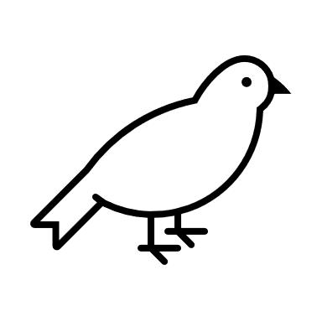 ** **

# Notes

Turn baked lighting back on for builds (Baked global Illumination)